**Exp 3** Design a door bell using push button

**CIRCUIT DIAGRAM**

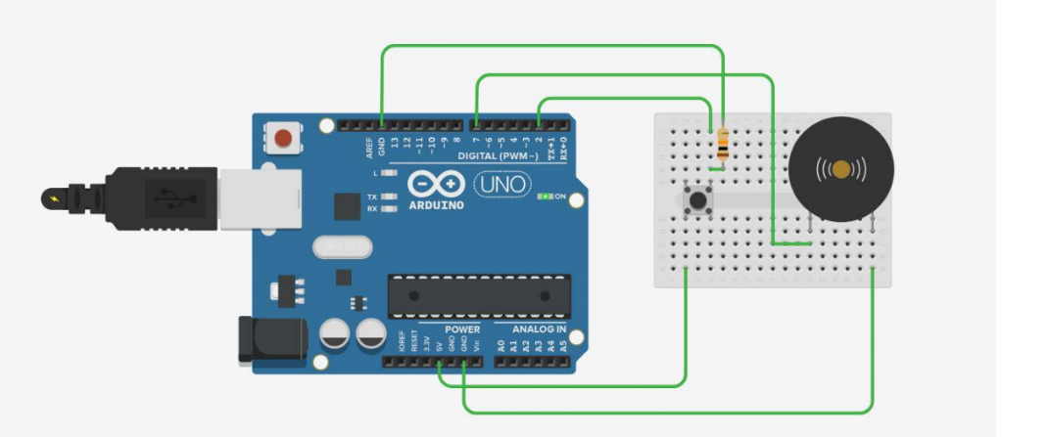

**THEORY**

**CONCEPT USED**

Whenever pushbutton is pressed door bell rings. Arduino provides power to the bell to ring .Pushbutton works as a switch which when pressed provide path to current to flow through it.

**LEARNING AND OBSERVATION**

Arduino can be used as a controller and used in an application of door bell.

**PROBLEM AND TROUBLESHOOTING**

While making the circuit, connection are needed to be maintained corrected. Problem which can be faced is only with the connections.

**PRECAUTIONS**

1. Connections must be tight and correct.
2. Coding must be right.
3. Components used must be working properly.
4. It is better to keep the circuit switched off when it is not in use.

**LEARNING OUTCOMES**

Using such system can make it easier for anyone to make their own door bell.